Computer networks

**Lab activity – 1**

**Name :** N.V.M.Sumanth

**Reg no :** 192111449

**Faculty :** Dr. S. Ramesh

**Course code :** CSA0786 computer networks for wanet applications

**Lab activity :1**

**1.Question -** Configuration of Topologies using Packet Tracer (Star, Mesh, Tree, Bus, Ring, Hybrid).

**1a) Star topology :**

**Step 1 : Take a PT switch**

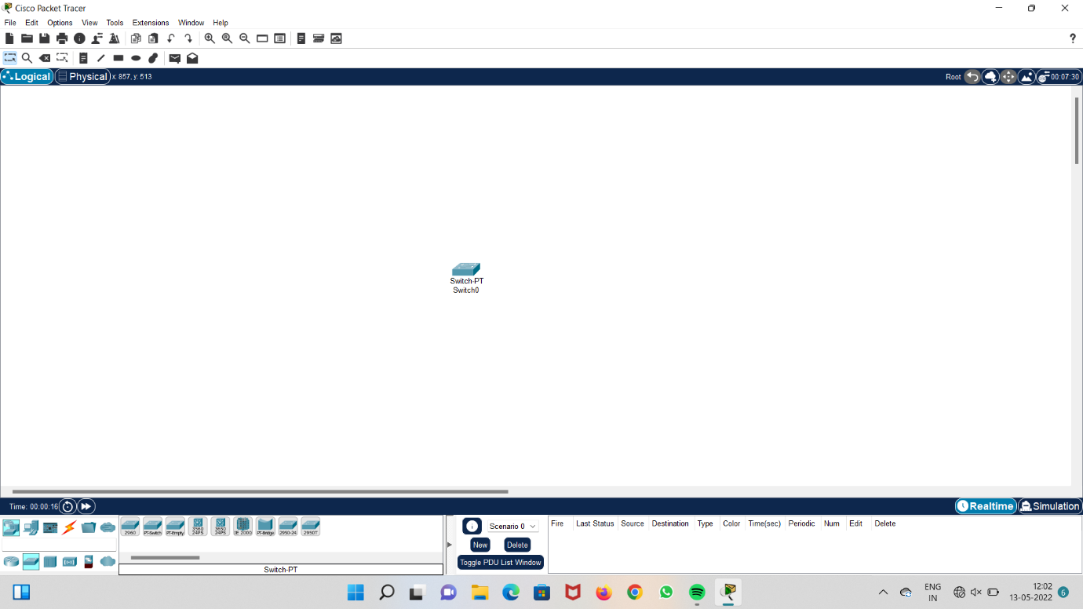

**Step 2 : Add six computers**

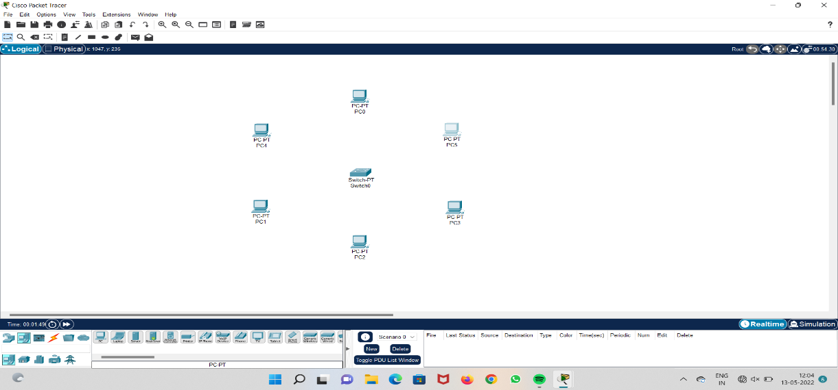

**Step 3: switch off PT switch and add two connects to it.**

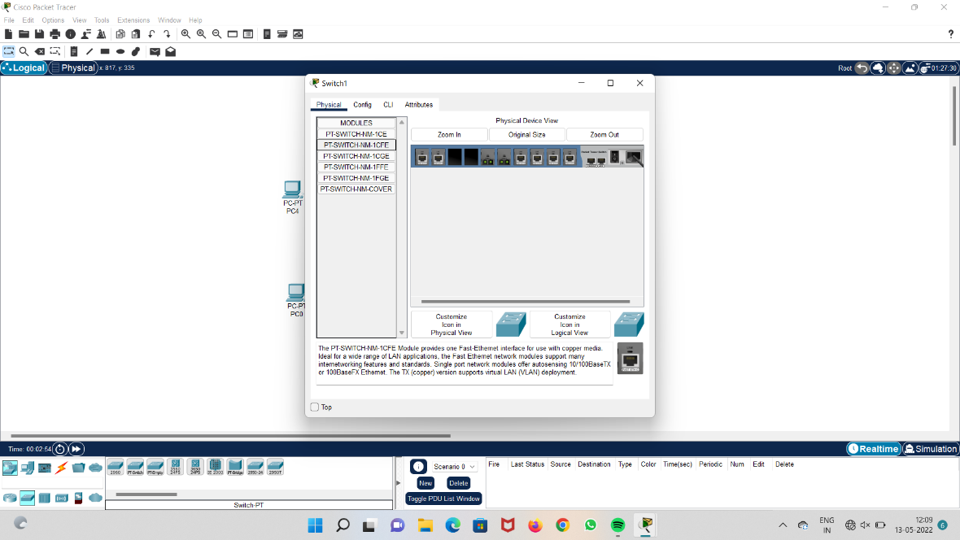

**Step 4: Take cables and connect all computers to the PT switch**

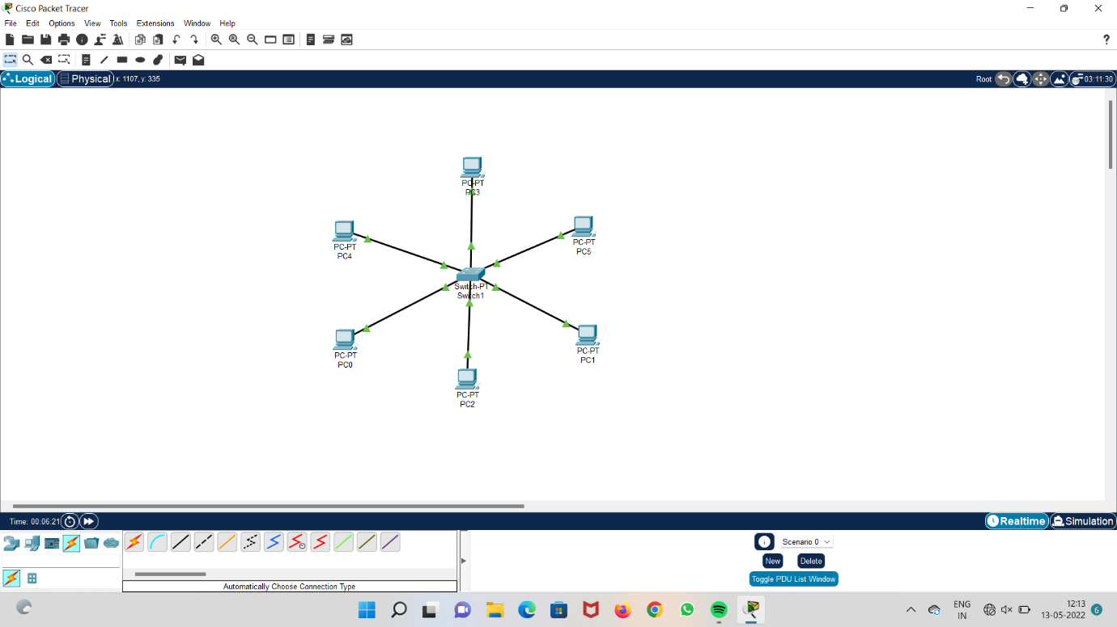

**Step 5 : add IP addresses to all the systems.**

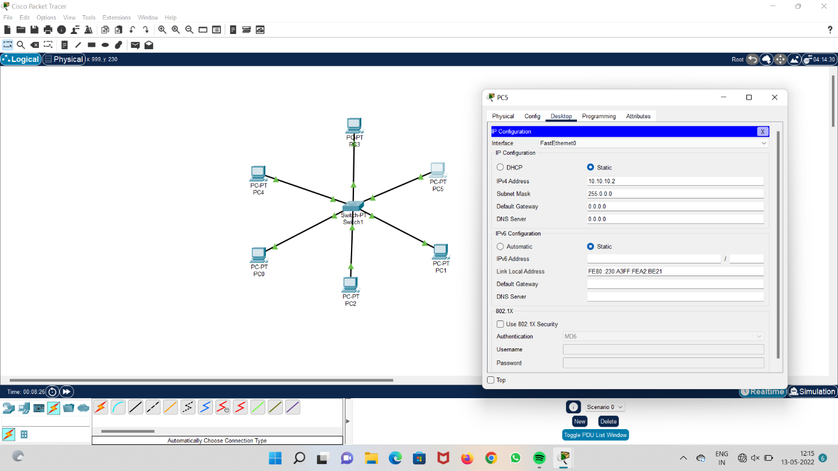

**Step 6 : Run the system and check acknowledgement.**

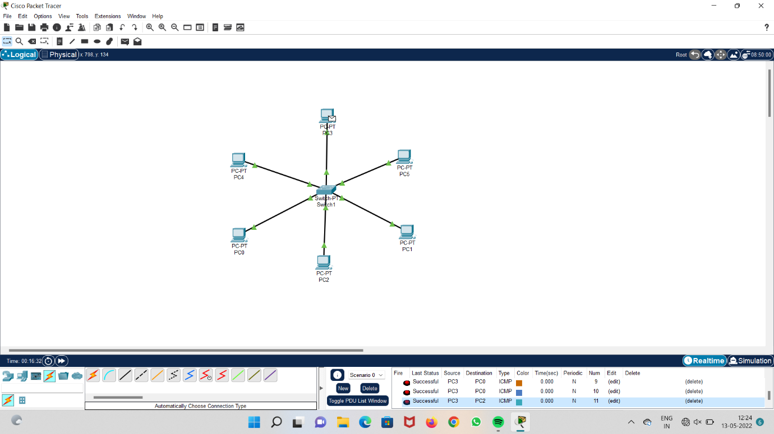

**1b) Mesh topology :**

**Step 1 : Add 4 PT switches.**

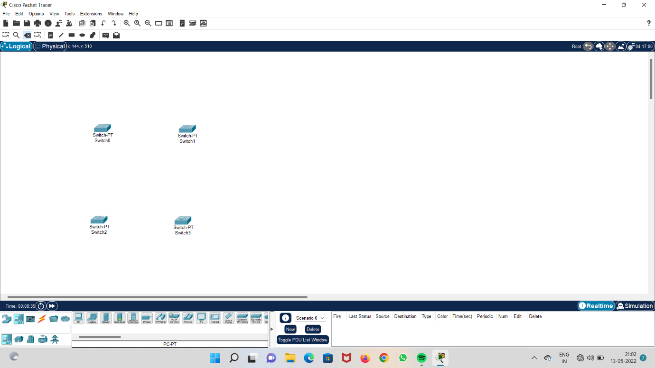

**Step 2 : Add 4 systems and connect all the 4 PT switches with wires.**

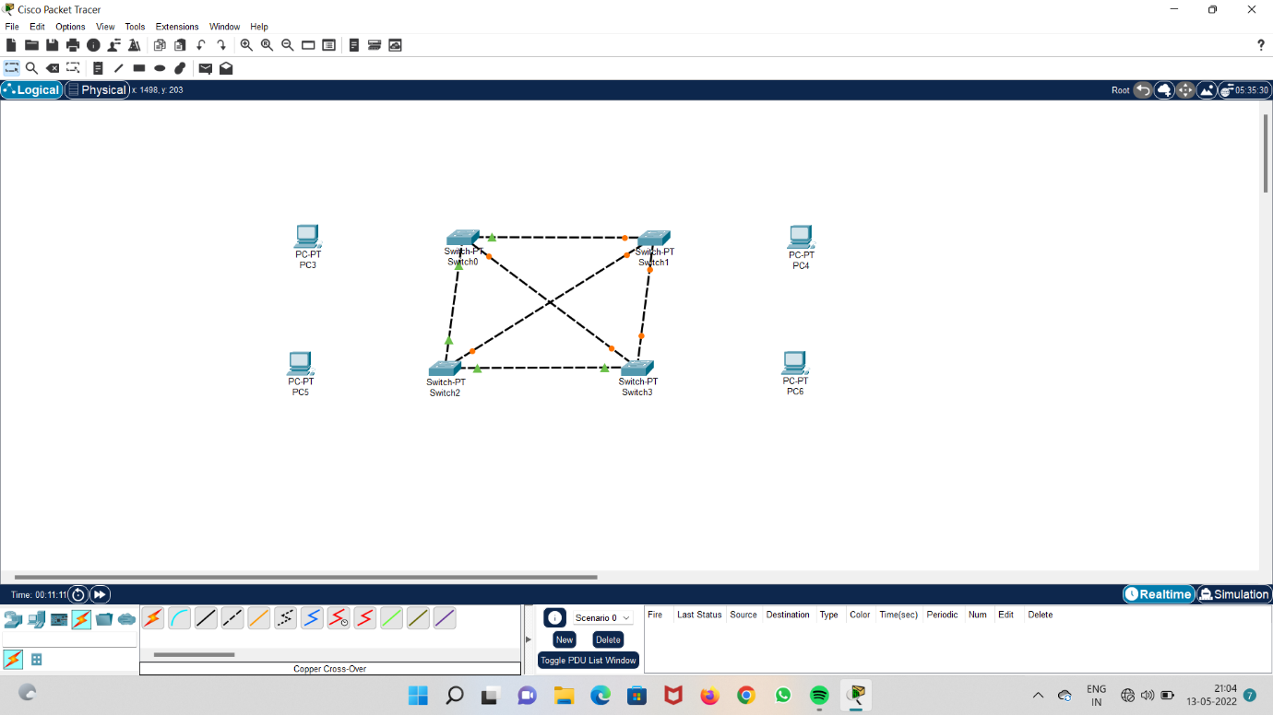

**Step 3 : connect all the 4 systems to the PT switches**

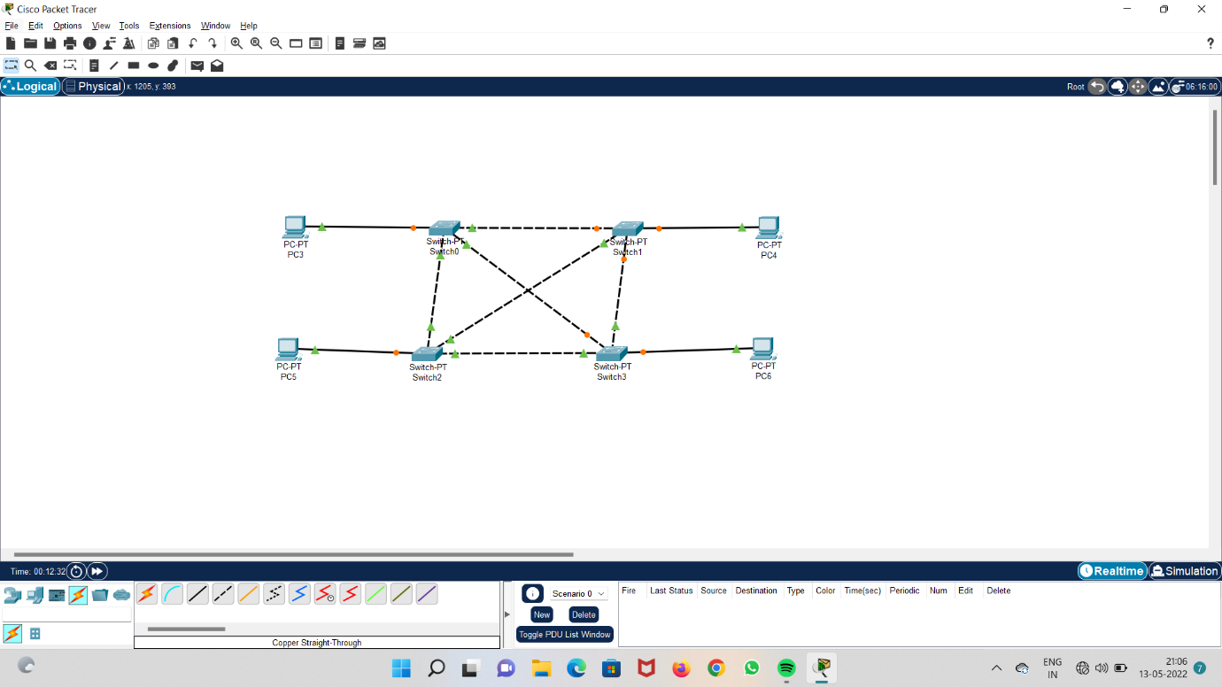

**Step 4 : Add IP addresses to the systems.**

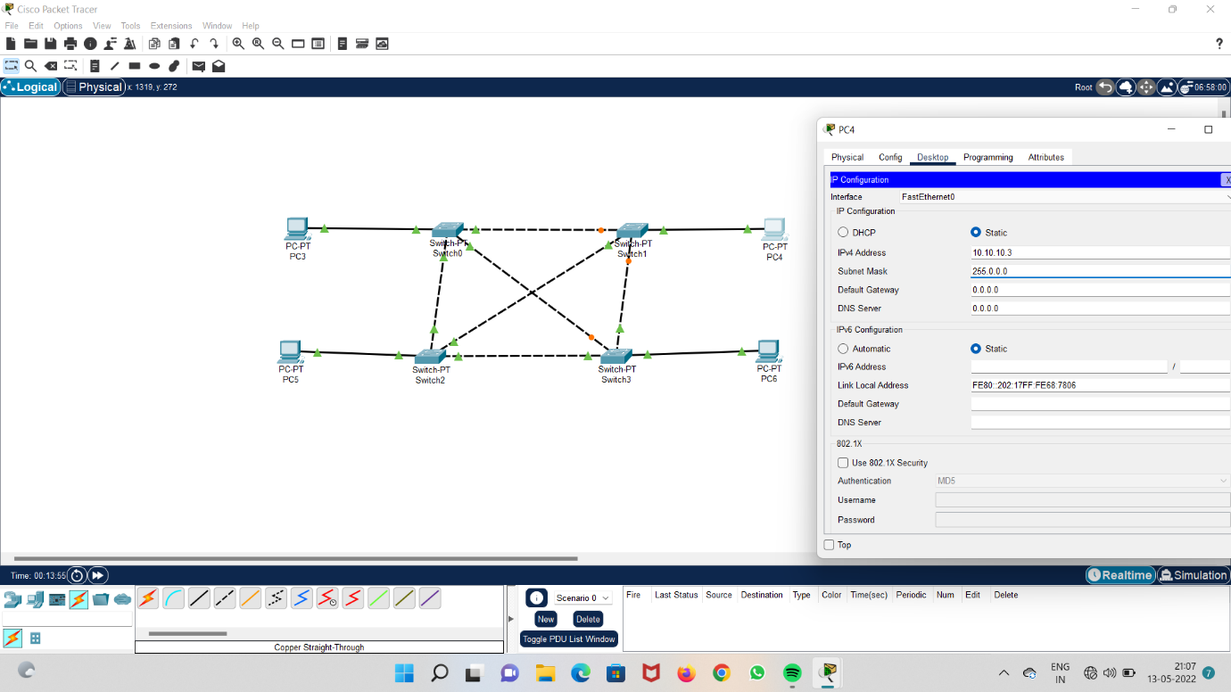

**Step 5: Run the system and check acknowledgement.**

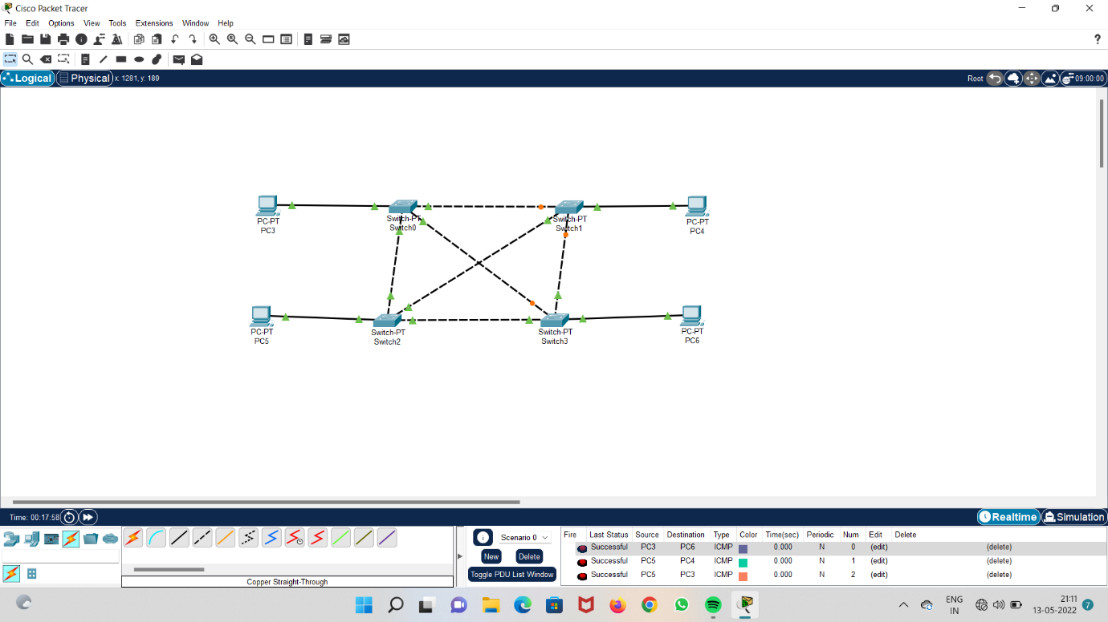

**1c) Tree Topology :**

**Step 1 : Add eight computers**

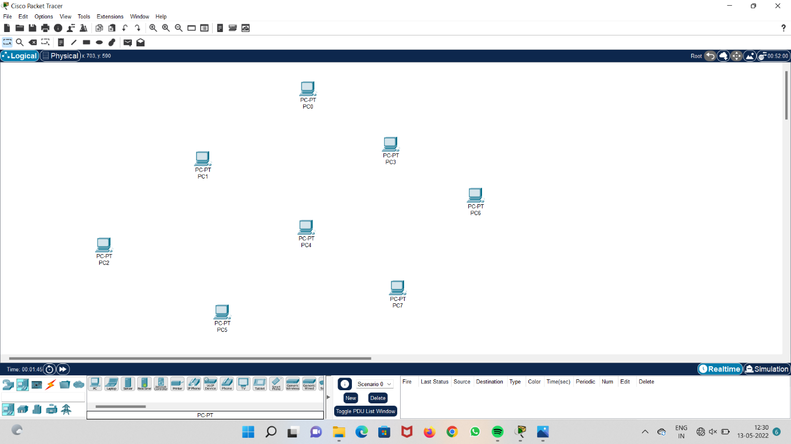

**Step 2 : add eight switches**

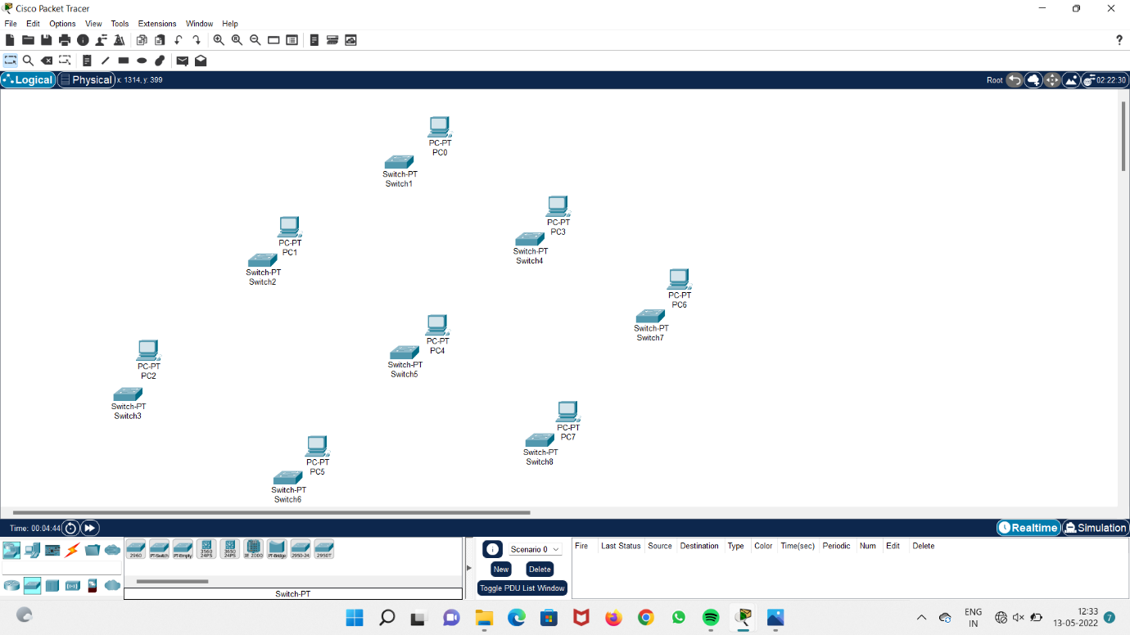

**Step 3 : connect all the switches to each other and connect computers to the systems.**

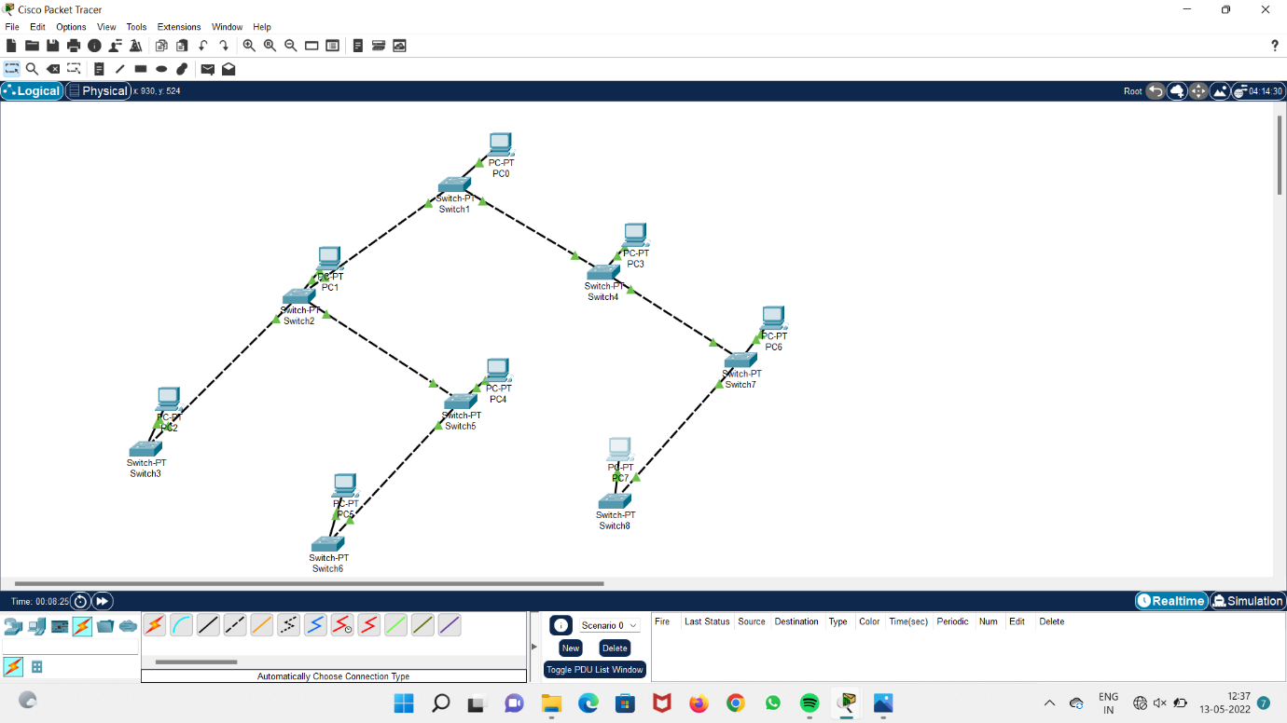

**Step 4 : Add IP addresses to the system**

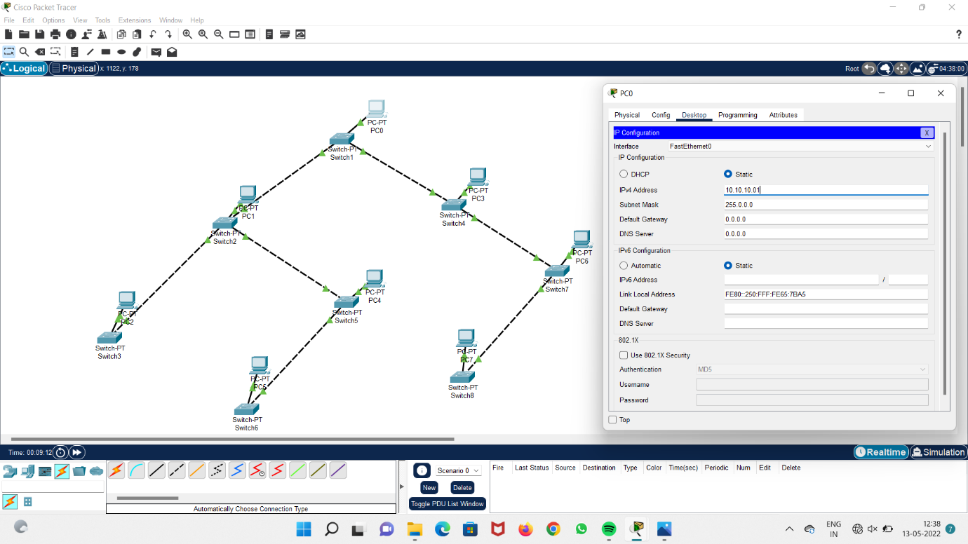

**Step 5 : Run the system and check acknowledgement.**

S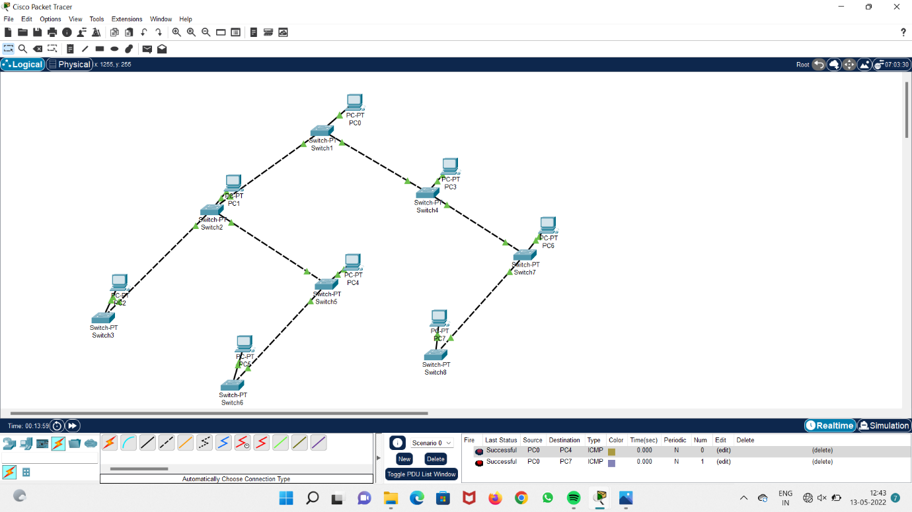

**1d) Bus topology :**

**Step 1 : Take four laptops.**

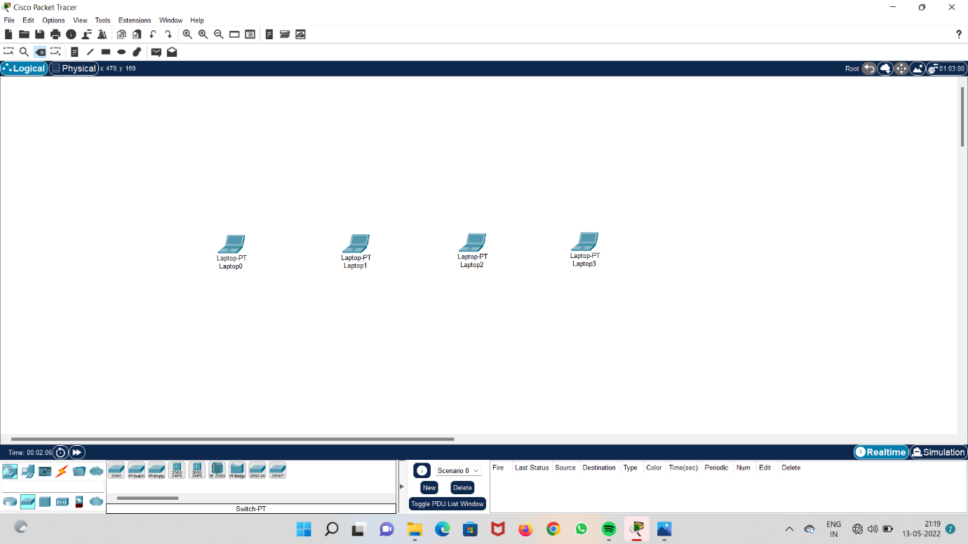

**Step 2: Take 4 switches**

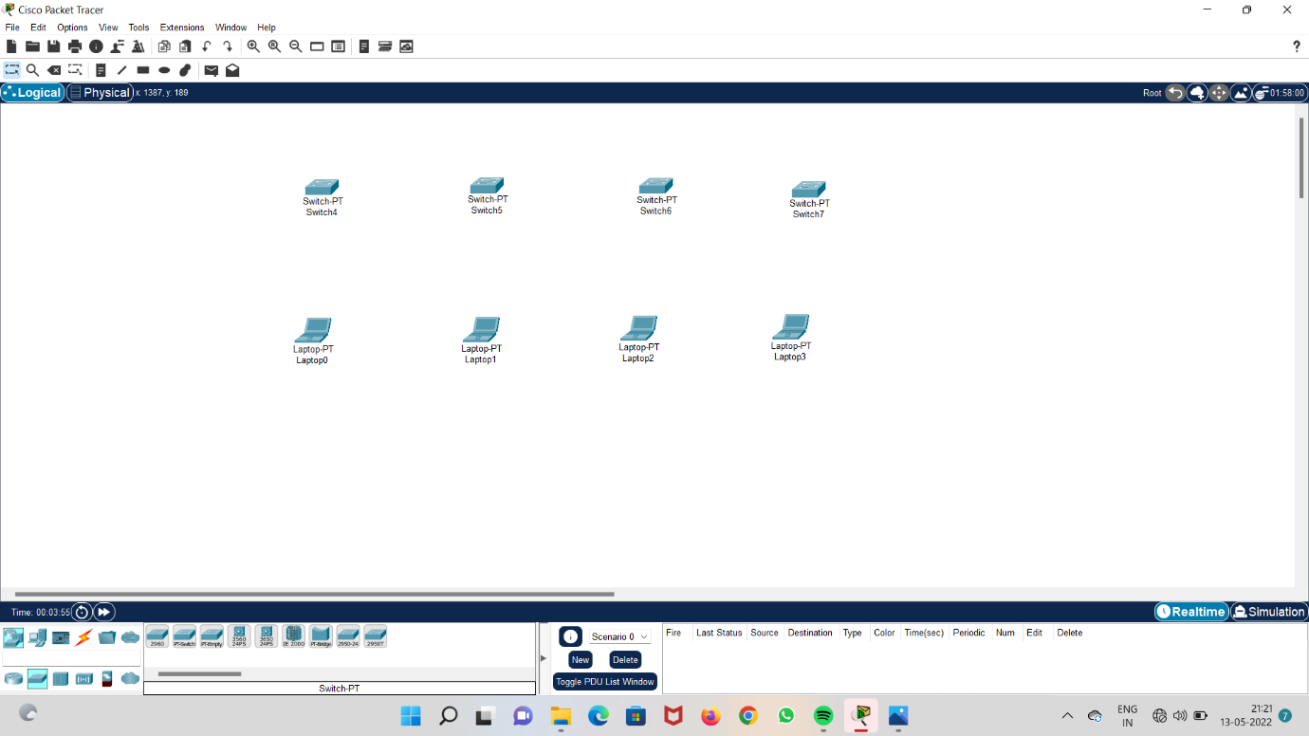

**Step 3 : connect all the four switches to each other**

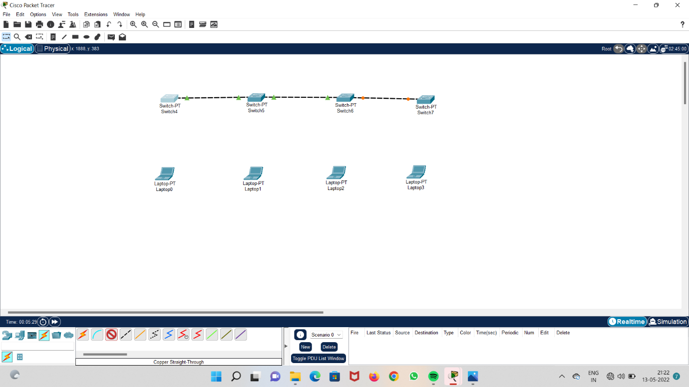

**Step 4 : connect all the switches to the systems.**

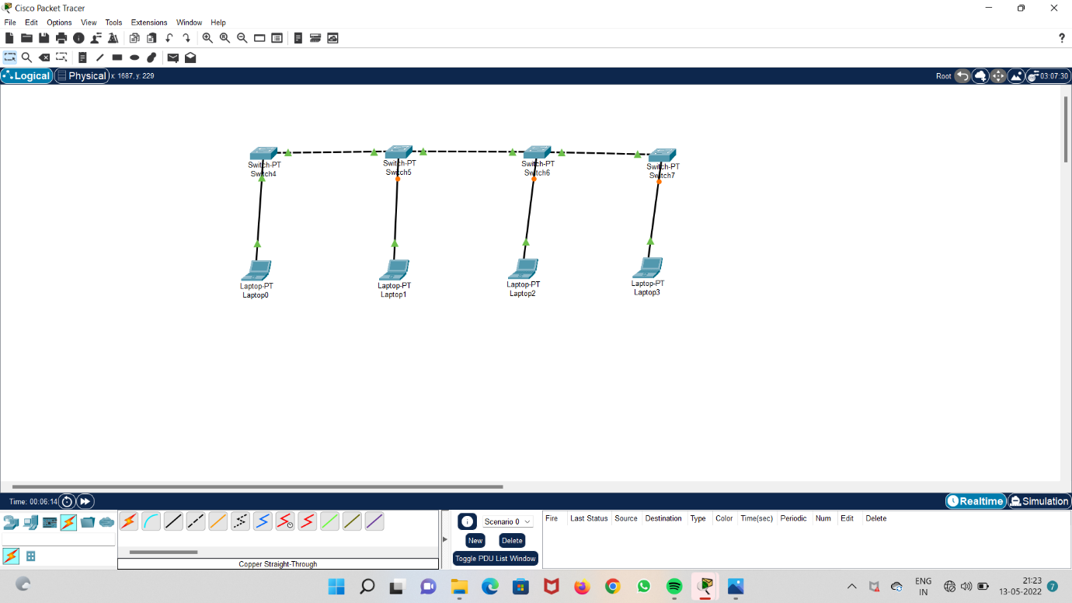

**Step 5 : Add IP addresses to the laptops.**

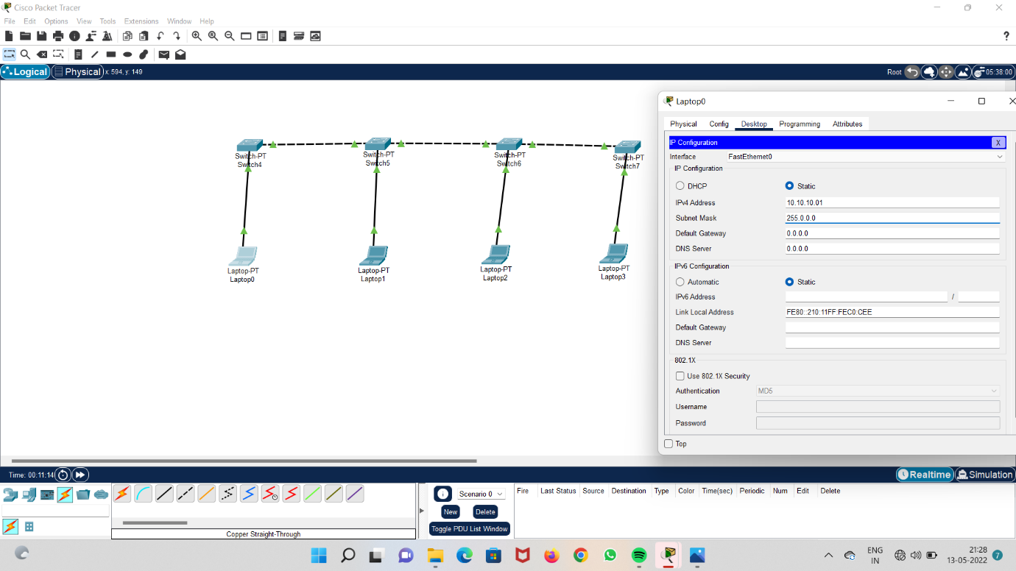

**Step 6 : Run the systems and check acknowledgement**

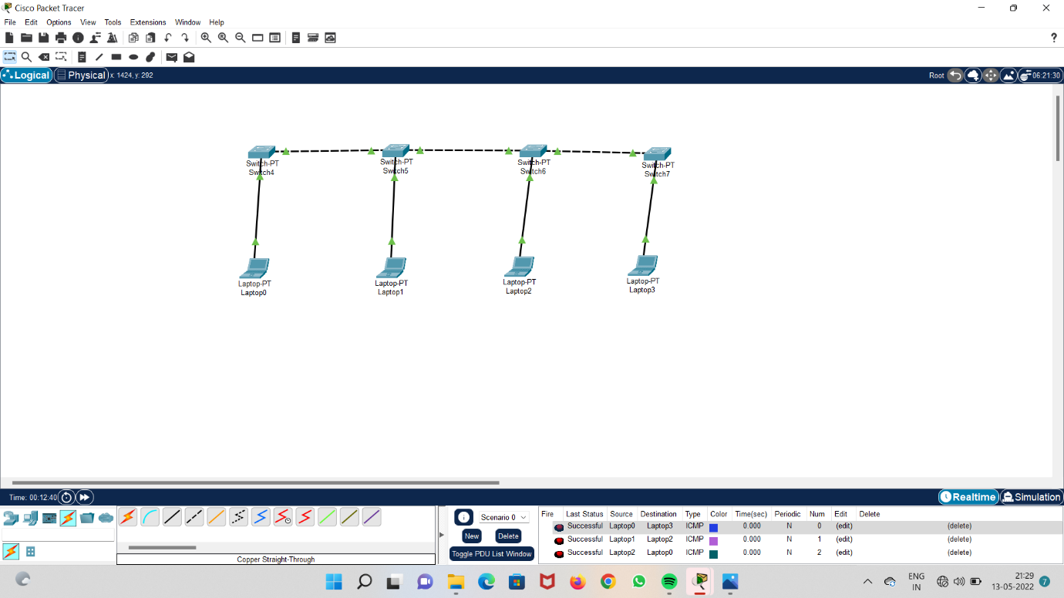

**1e) Ring topology :**

**Step 1 : Take four laptops**

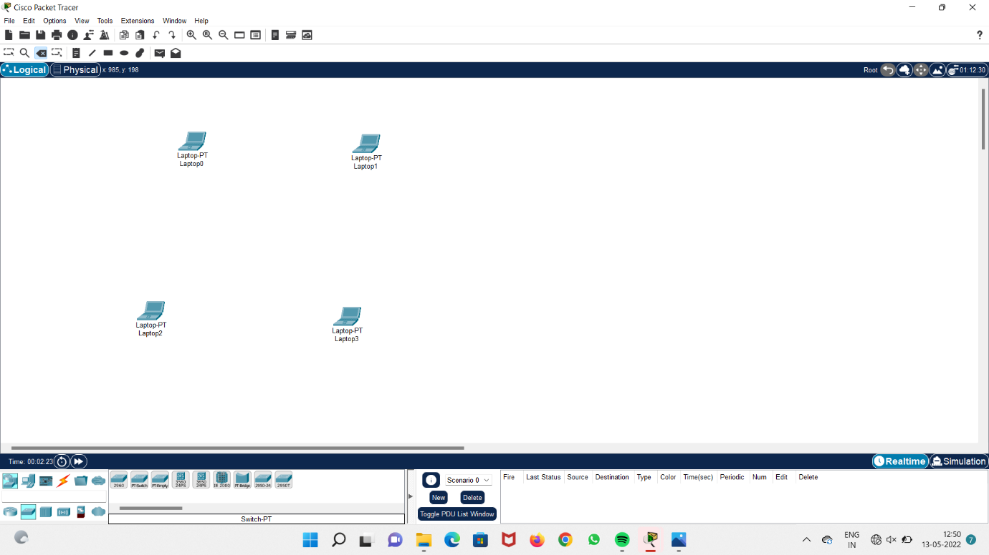

**Step 2 : Take four switches.**

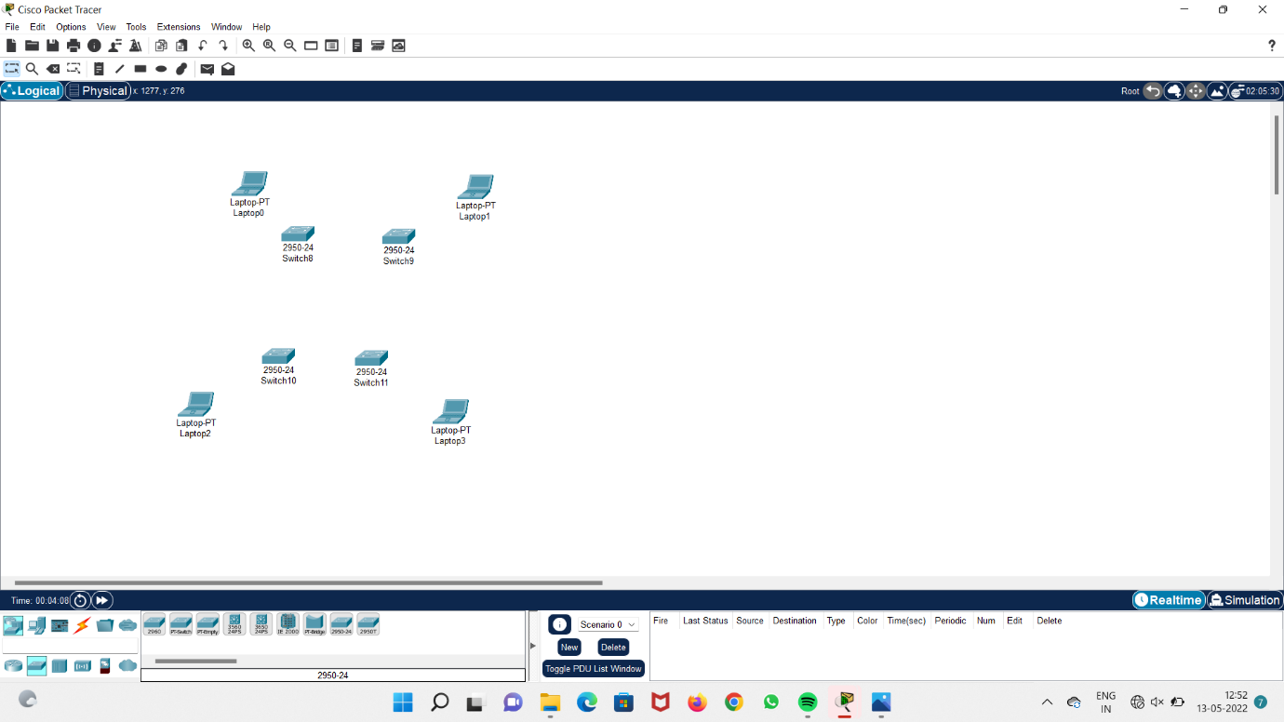

**Step 3 : connect all the four switches to each other.**

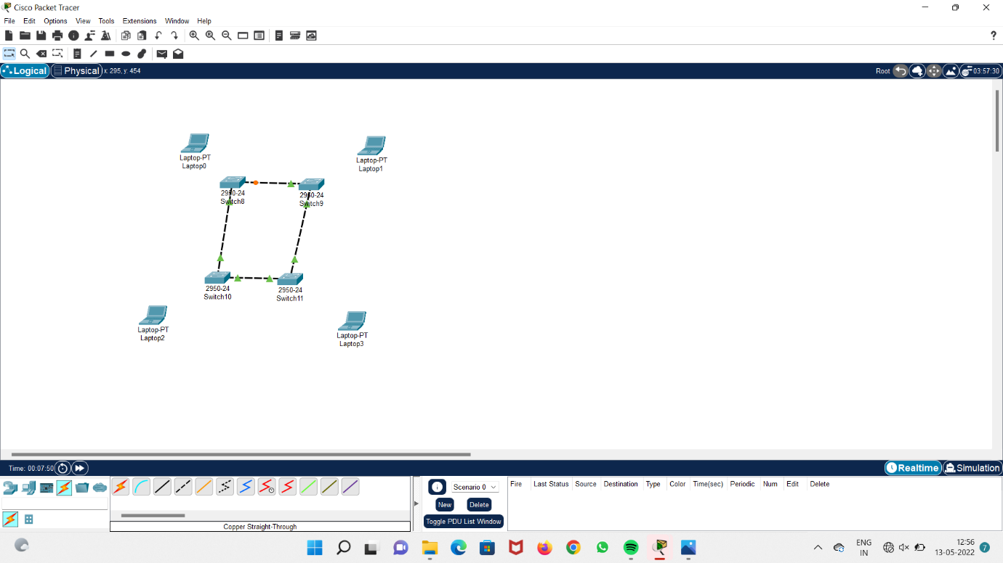

**Step 4 : connect all the laptops to the switches.**

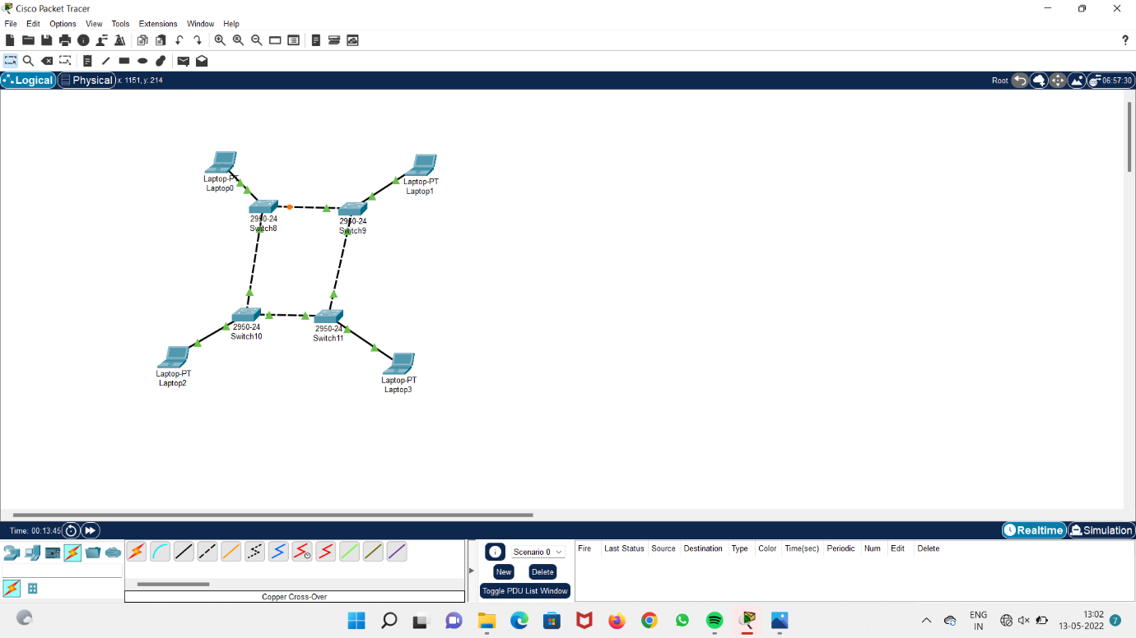

**Step 5 : add IP addresses to the systems**

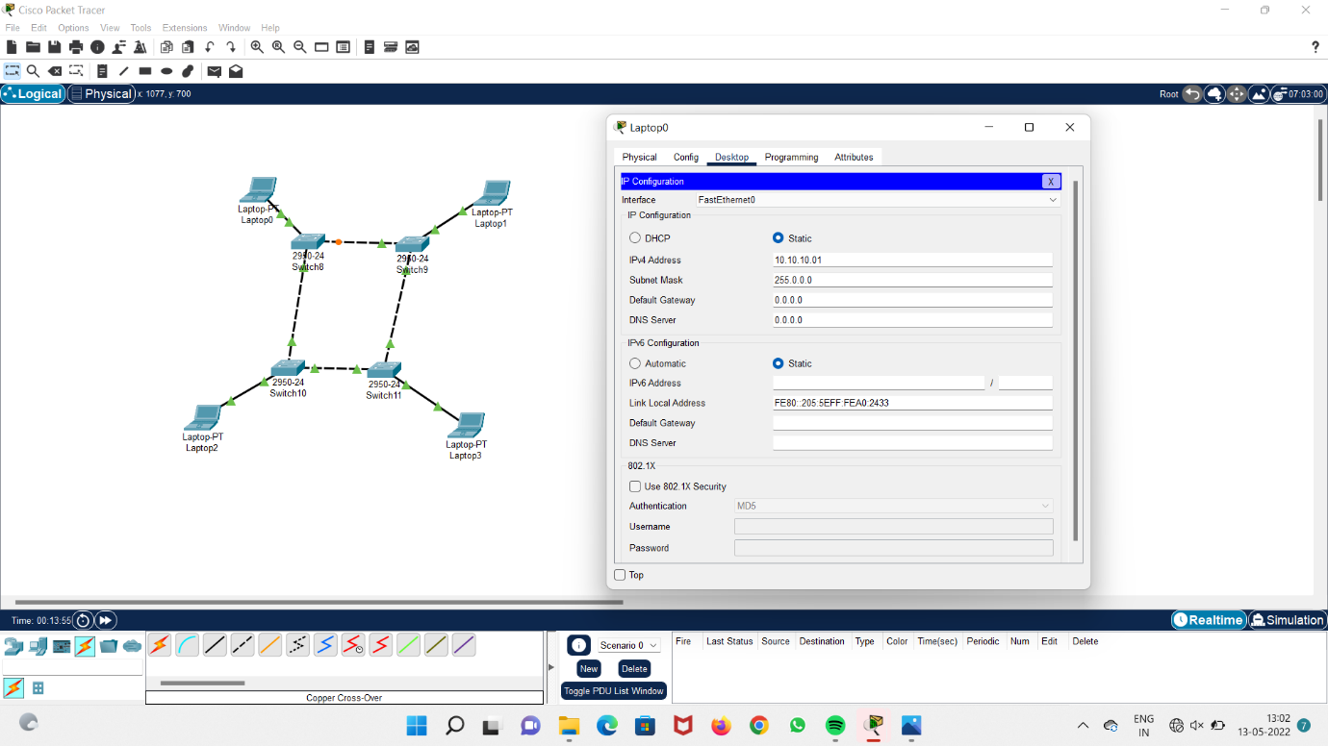

**Step 6 : Run the systems and check acknowledgement**

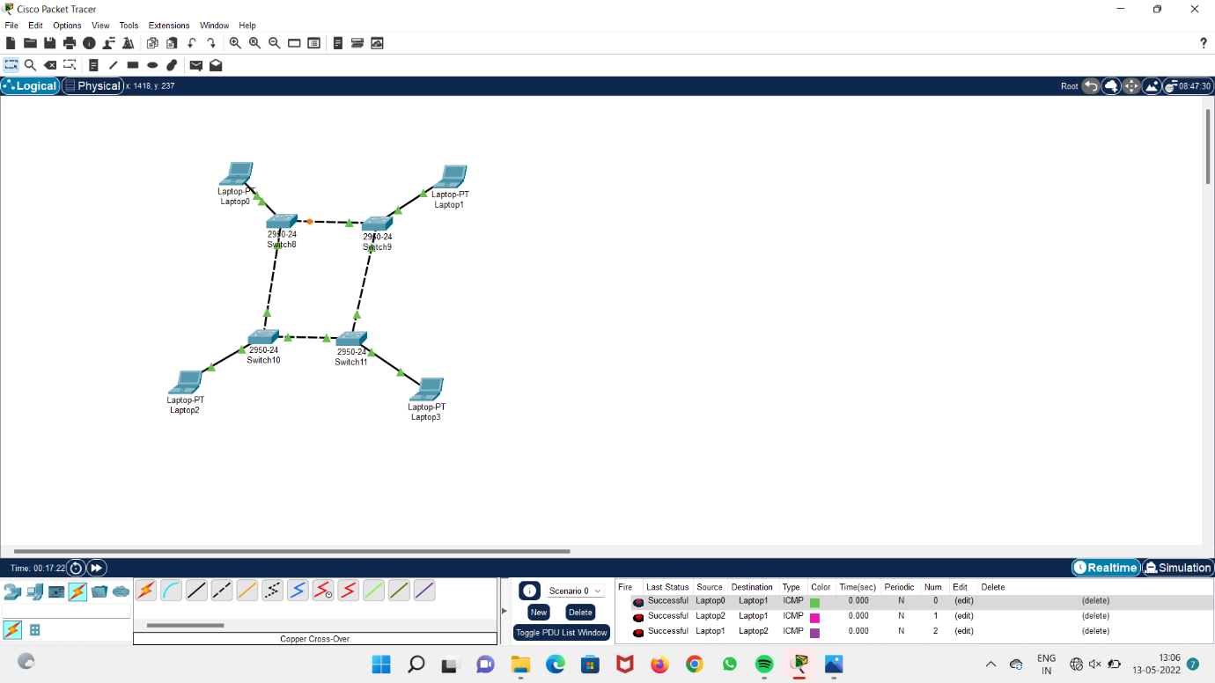

**1F) Hybrid Topology :**

**step 1 : Take 8 switches.**

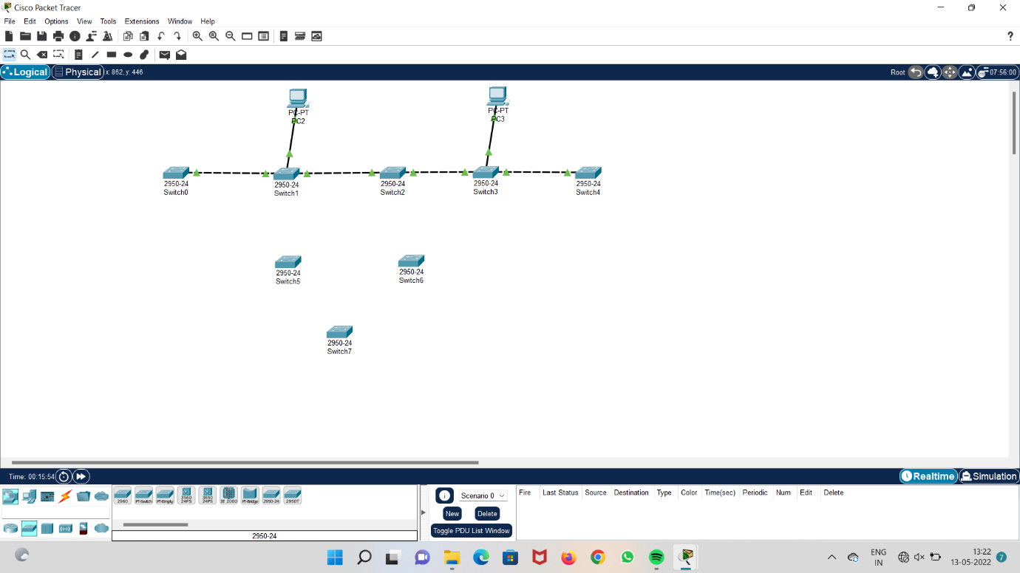

**Step 2 : Take 5 computers and connect them to switches.**

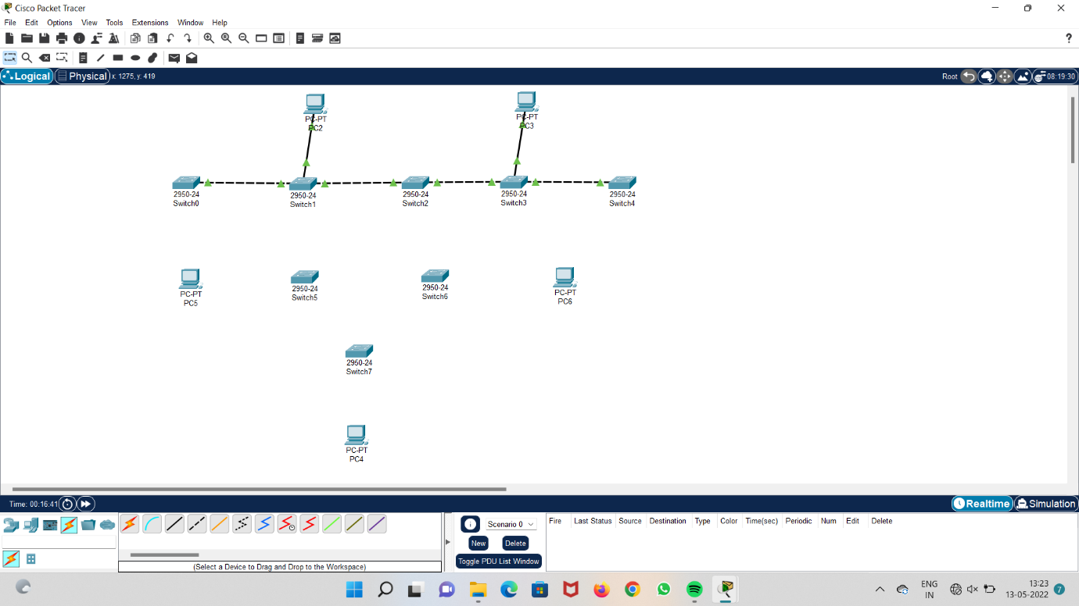

**Step 3 : connect all the switches to each other.**

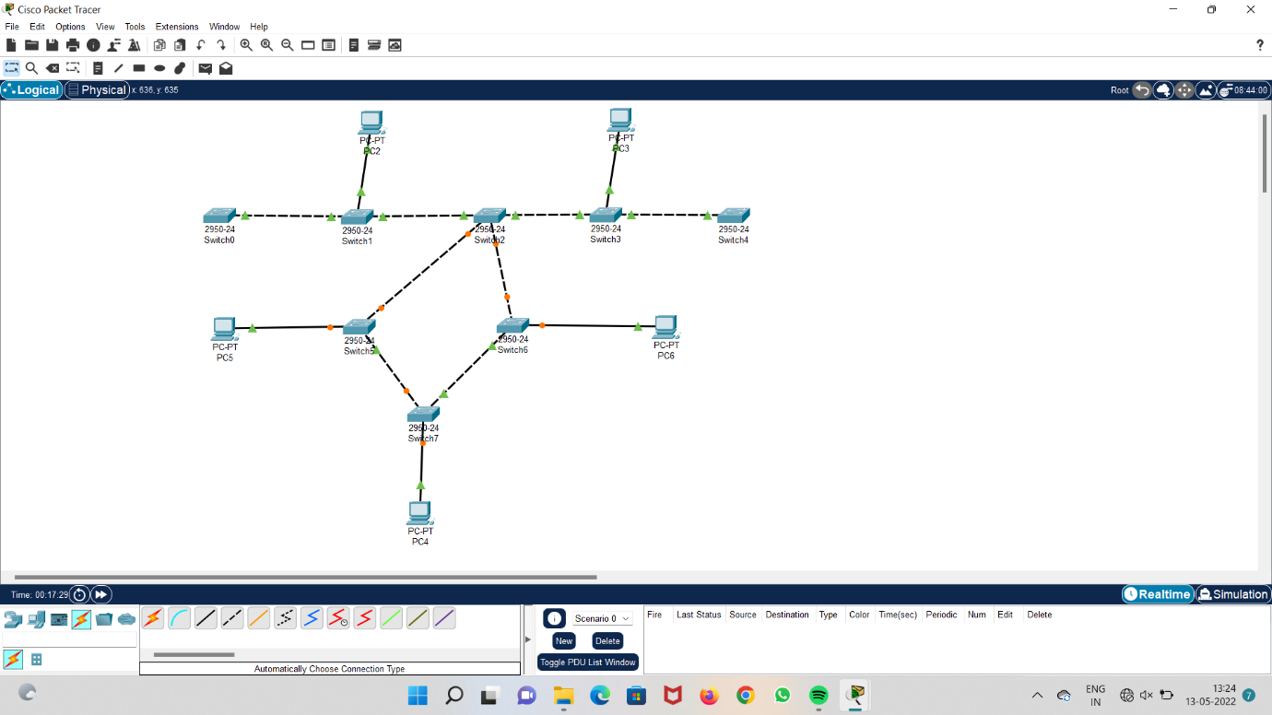

**Step 4 : Add IP addresses to the system.**

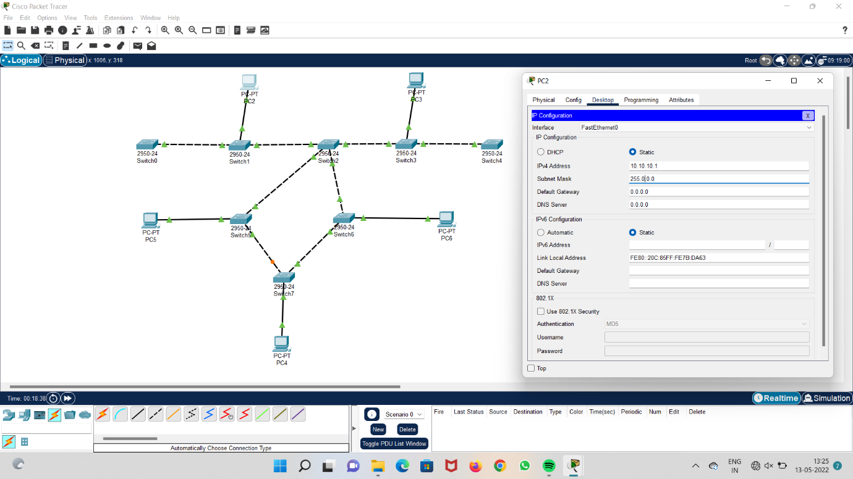

**Step 5 : Run the system and check acknowledgment.**

